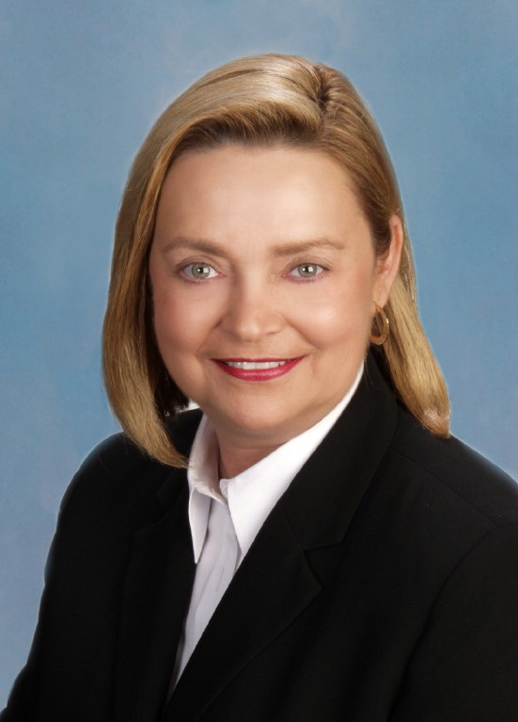
THE BOISVENUE REPORT

Liquefied Natural Gas Ports Proposed Off Fort Lauderdale Beach

Just when you thought you had heard it all. While talking with leaders I was handed a fact sheet which I absolutely must share with you. The article in the Sun Sentinel on May 2008 in the local section has everyone’s lips buzzing. It seems that the governor has the power to stop this and please take the time to call or email him and if you are really angry take a trip to see him.

Here is what I read. Much of it I could research and see it online. A public hearing will be scheduled and will be the last opportunity for residents of Fort Lauderdale to express their opinions publicly about proposed liquefied natural gas ( LNG) deepwater ports off our coast, before final approval by Governor Crist. Suez Energy North America, under its subsidiary named Calypso, would build the ports, which will be visible by the naked eye from the beach, and look something like a ship on the horizon.

Background

The original plan of the Suez Company was to unload its ships containing LNG in a port in the Bahamas so it could flow through a pipeline to Florida. The Suez company failed to get approval from the government in the Bahamas for this plan.

LNG is frozen natural gas, maintained at extremely cold temperatures. In liquid state, the gas is not flammable I am told. It is heated on the vessel at the time of discharge into a pipeline, at which time its fumes are highly flammable. If the substance melts too quickly, such as caused by an accident or sabotage, a violent and devastating explosion can occur. One vessel transporting liquefied natural gas has the equivalent and explosive power of some 20-55 A-Bombs.

Description of the system

There are two basic subsystems making up this LNG deepwater port delivery system. First, are the deep water ports, and second is the pipeline running from the ports on the ocean floor through the coral reef into Port Everglades.

The deepwater ports consist of two docking ports, one located 8 miles off our beach and the other 10 miles. Vessels with LNG will anchor there and the gas will be heated onboard the vessel and discharged into the connecting pipeline. This vessel will be visible from our beach near the horizon. A second port will house a permanent ship, which will serve as a moor providing additional capacity for ships to discharge gas. It will house five gas storage tanks.

The pipeline, which will carry gas from the two ports, will rest on the ocean floor until it reaches the coral reef in a tunnel. It will surface in Port Everglades, and connect into a Florida gas pipeline.

WHY CITIZENS SHOULD OPPOSE THE LNG PORTS

The first LNG onshore facility leveled one square mile of Cleveland Ohio in 1944, killing 181 people, and leaving 680 homeless. A similar explosion occurred in 2004 in Algeria. There are no LNG deepwater ports off our coastline - so what could happens unknown. The concerns are many:

- One ignited vapor cloud explosion is capable of traveling 30 miles inland from the ocean docking port – endangering Fort Lauderdale and Broward County.
- Once the gas dispersion level is exposed to oxygen, it will ignite from a simple spark – thus creating a fireball.
- Fire departments have no way to extinguish such a cloud – it has to burn itself out.
- LNG ports would be a perfect terrorist target – Suez Energy plans to have a patrol boat monitor the area and contact the Coast Guard if there is a problem.
- A 2001 study considered an LNG deepwater port facility a security risk and recommended that it should be avoided.
- Tankers on the Ocean’s horizon would be 3 football fields long and 17 stories high.
- One tanker holds 33 million gallons of LNG – which equals 20 billion gallons of natural gas – an explosion that would have the power of 20-55 Atomic bombs.

GOVERNOR CRIST HAS THE POWER TO STOP THIS!
Unless our voices are heard, we will have LNG deepwater ports right off our beach.
Local officials need to speak out and oppose this project.
Let Governor Crist know we do not support this environmentally dangerous LNG deepwater port – threatening our beaches, our city, our environment and our county. Email www.flgov.com. Write the Capitol 400 S. Monroe Street Tallahassee, Fl 32399-0001, Phone 850 488 4411 and e-mail
charlie.crist@MYFLORIDA.COM

Suzanne Boisvenue is a Registered Nurse and a Commissioner in the City of Oakland Park, Fl. and can be reached at Phone 954 298 8899 suzanneboisvenue@hayoo.com

