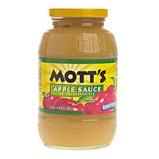

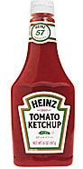
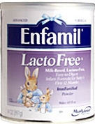
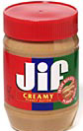
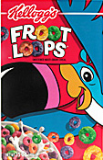
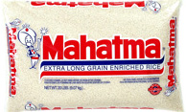
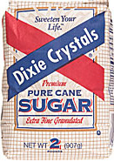

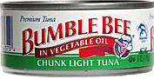



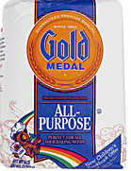
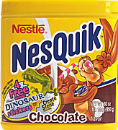

Name of your Association
Contact Person:
Mailing Address:
Contact Phone Number: | ( )
Email address:

Scott A Woodburn
The Cooperative Feeding Program, 1 NW 33rd Terrace, Fort Lauderdale, FL 33311
(954) 792-2EAT Fax (954) 792-9982
www.FeedingBroward.org

A request for your Condo Association to be an important part of the 2009 GALT Ocean Mile campaign to reduce hunger in Broward County...
Please indicate when we can appear before your Association.

____________, ____________, ______________________
Date Time Location

Please complete form and return to address below to the attention of Scott Woodburn or fax to (954) 792-9982.
THANK YOU!

Yes! We’ll do a MARCH Food Drive in cooperation with the Galt Ocean Mile Condo Associations & Cooperative Feeding Program to feed the hungry!

to benefit

