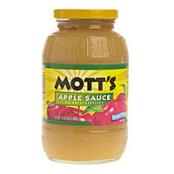
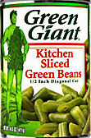
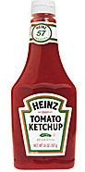
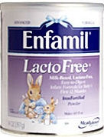
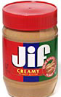
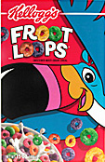
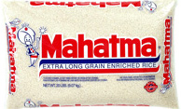
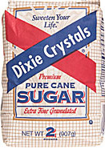
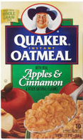
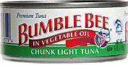
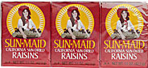
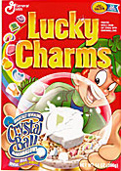
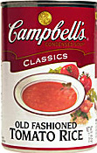
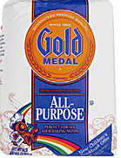
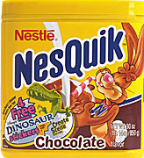

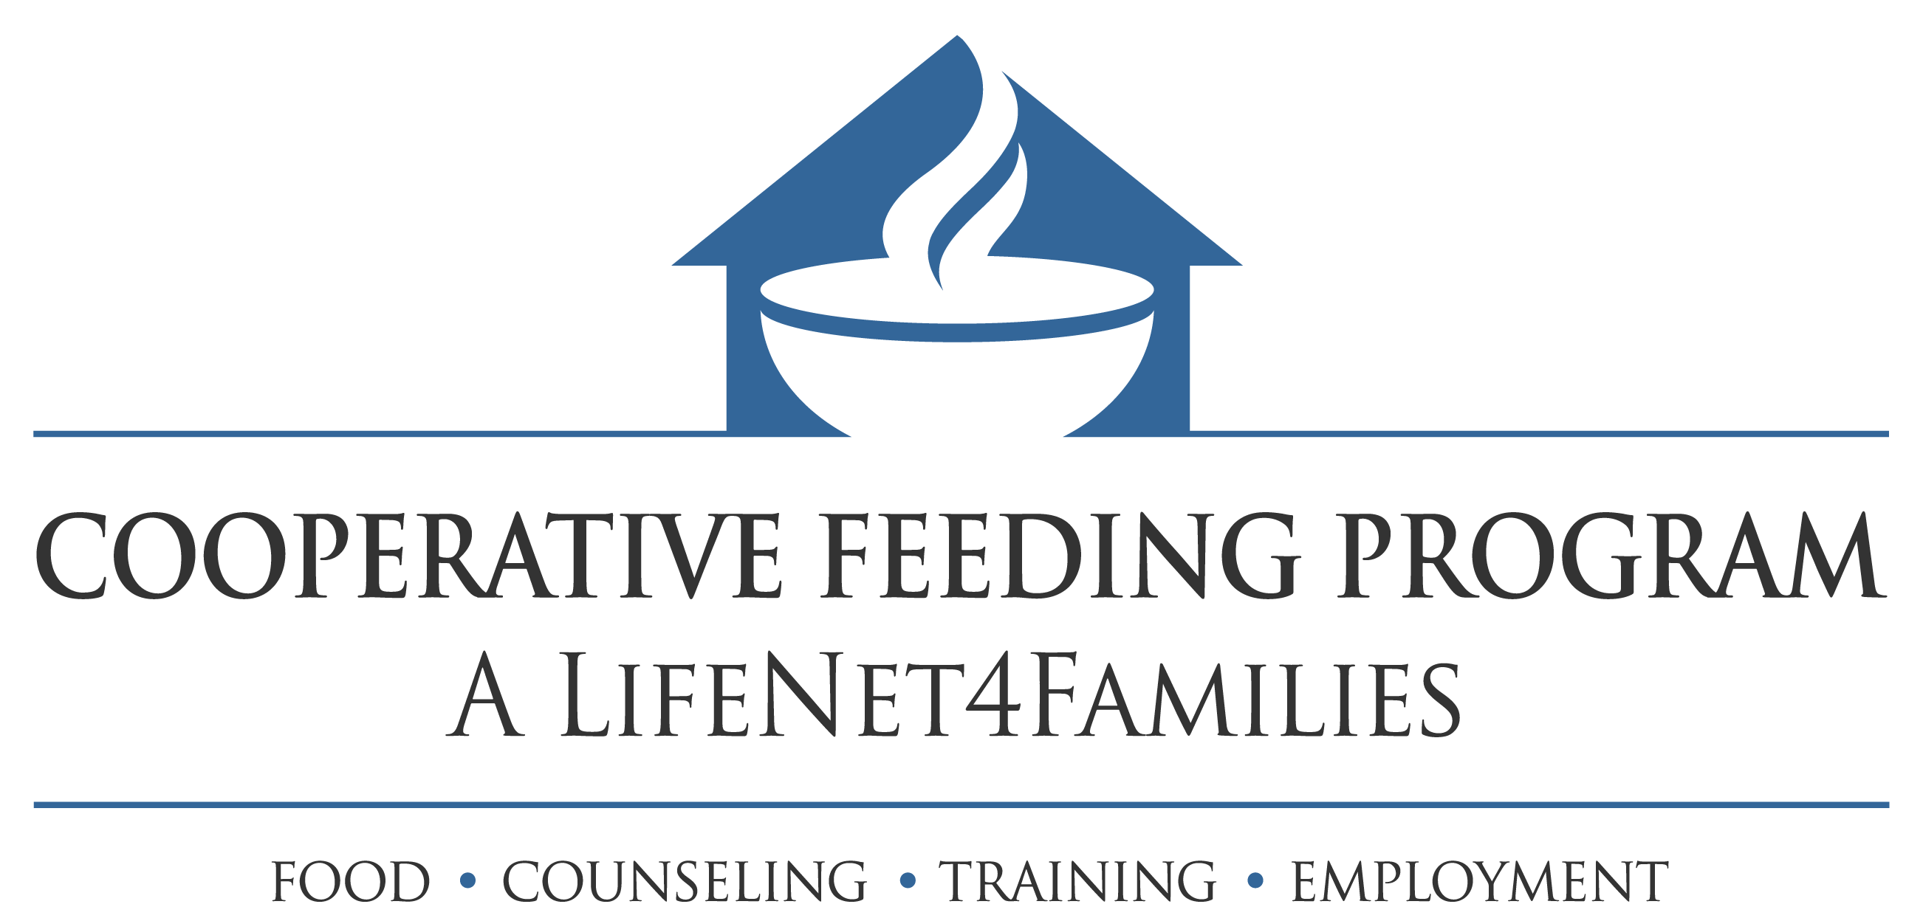
Our 2008 Galt Food Drive, which included 21 Galt Condo Associations, was a huge success. Over 11,000 lbs of food and money donated and the Edgewater Arms was crowned Champion Condo Association.

Once again we are poised to initiate the 3rd Annual Galt Ocean Mile Food Drive. CFP Director and Committee Chair Domenic Faro, of L’Hermitage invites the entire Galt Ocean Mile Condo Association to join our campaign and participate in another exciting Galt Ocean Mile Food Drive.

The month of March has been designated the 2009 GALT Ocean Mile Food Drive month. A special “Walk against Hunger” will kick off the month long Food Drive.

We have the food collection boxes, posters, mail box stuffers and flyers to help you announce the walk and food drive to your residents and provide a description of what types of non-perishable items are needed.

We will also work with each Condo Association to advise you on organizing the food drive, promotional considerations, food collection and handling pick up and delivery to the Cooperative Feeding Program.

Please take a moment to fill out and fax to us the attached form ASAP. We also would appreciate an opportunity to meet with you and make a presentation to your Condo Association at your next meeting. Please RSVP and confirm the date of our appearance before your Board.

Hunger remains a real problem in Broward County as 1 out of 4 goes to bed hungry every night. With your help, fighting it will be as easy as A-B-C!

Sincerely,

Scott A Woodburn
Cooperative Feeding Program
954-629-7381

Cooperative Feeding Program
1 NW 33 Terrace, Ft Lauderdale, Florida 33311
954-792-2328, fax 792-9982
www.feedingbroward.org

A request for you to
Be an important part of the 3rd Annual GALT OCEAN MILE
Campaign to reduce hunger in Broward County...

