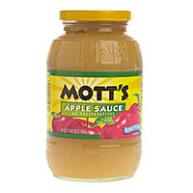
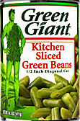
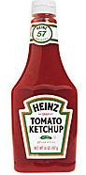
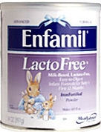
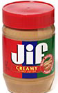
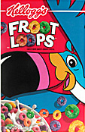
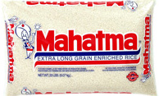


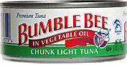
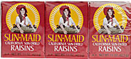

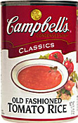

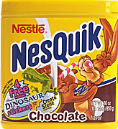

A request for you to
Be an important part of the
Campaign to reduce hunger in Broward County...

3rd Annual
GALT Ocean Mile
Food Drive

Kick Off Event
“WalK Against Hunger”
SUNDAY, MARCH 1st

Food Drive
MARCH 1 – 31st

Thank you for helping to feed
Broward families in need.

The Cooperative Feeding Program
1 NW 33rd Terrace, Fort Lauderdale, FL 33311
(954) 792-2EAT (2328)
www.FeedingBroward.org

